**Rafting Project Info Sheet** – McKenna Johnson

WDD 130

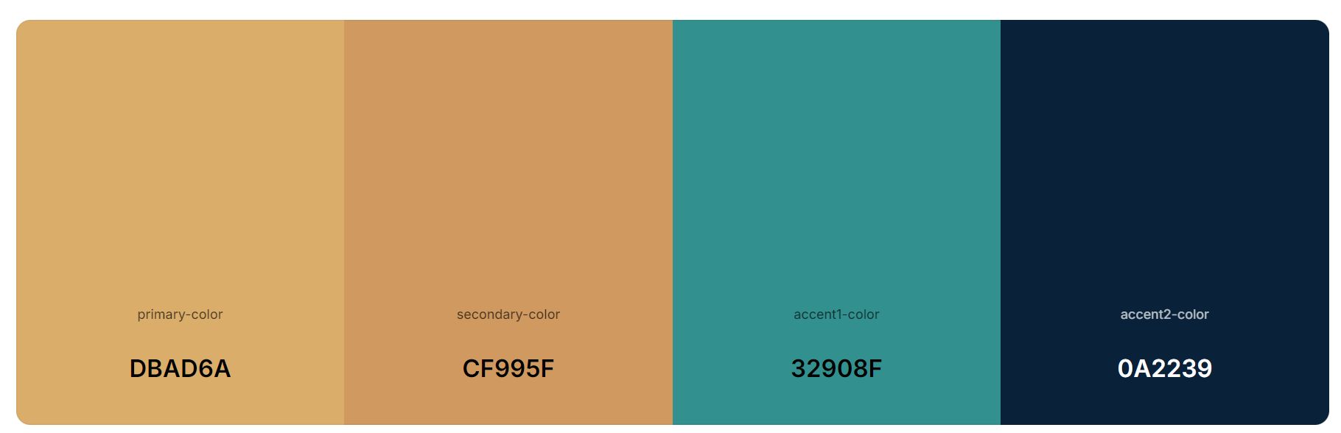

**Color Palette URL:** <https://coolors.co/user/palettes/66fe16a6407793000b67e98e>

* Primary-color: **DBAD6A**
* Secondary-color: **CF995F**
* Accent1-color: **32908F**
* 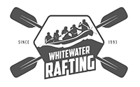Accent2-color: **0A2239**

**Logo:**

**Typography:**

* Heading-font:
  + Anton SC
  + @import url('https://fonts.googleapis.com/css2?family=Anton+SC&display=swap');
* Text-font:
  + Afacad Flux
  + @import url('https://fonts.googleapis.com/css2?family=Afacad+Flux:wght@100..1000&family=Anton+SC&display=swap');